PRESS RELEASE: SPECIAL OLYMPICS FLORIDA
Media contact:
Laurie A. Moyson, Special Olympics Florida
352-243-9536 x525
lauriemoyson@sofl.org
www.specialolympicsflorida.org
UPCOMING EVENTS
February is one of the largest fundraising months for Special Olympics Florida, and RP Funding (see story below) is the title sponsor for three major events that have excellent media-related opportunities:
Polar Plunge: A large crowd will brave the “icy” cold waters at Aquatica Feb. 2 at 11 a.m. (registration begins at 9:30). For just $100 in pledges, plungers and two spectators get entry into Aquatica, an all-day food pass and T-shirt. Anyone can participate.
Orlando Chili Cook-Off: On Feb. 9, competitive-eating champion Joey Chestnut headlines the fourth annual Orlando Chili Cook-Off, which runs from noon to 6 p.m. at Festival Park in downtown Orlando, next to Orlando Executive Airport. Event proceeds benefit Special Olympics Florida.
Special Olympics Rocks! On Feb. 16, from 6 to 11 p.m. at the Waldorf Astoria Orlando, Special Olympics Rocks! will provide a night of fun, entertainment, gourmet cuisine, auction items and, of course, live music. Athletes, coaches and parents will provide personal stories about the role Special Olympics plays in their lives.
See www.specialolympicsflorida.org for more information on each event.

RP FUNDING TEAMING UP WITH
SPECIAL OLYMPICS FLORIDA
Robert Palmer taking the “Polar Plunge” Feb. 2 at Aquatica
to raise funds for Special Olympics Florida athletes
Robert Palmer knows what it’s like to overcome adversity. So does Kristin Costanzo.
Now, they’re teaming up to “take the plunge” and provide life-changing opportunities for Special Olympics Florida athletes.
Watch enough TV, and you’re sure to see the face — that cherub-like smile from a dark-haired young man in front of an RP Funding logo. That’s Robert Palmer, the 33-year-old whose Orlando-based startup company has, virtually overnight, become a local leader in the mortgage-lending industry.
Quite an accomplishment for a guy who dropped out of UCF as a freshman.
With his vast advertising campaign and “Saving Thousands” TV and radio programs, Palmer’s brand has exploded over the past year. RP Funding has grown to 85 employees and nearly $300 million in annual sales, earning an impressive new title for its owner — Orlando Business Journal’s 2012 Outstanding Small Business Executive of the Year.
With such rapid success, Palmer felt called to sponsor a charitable outreach. In September 2011, despite knowing very little about the organization, he and his company became involved with Special Olympics Florida. A short time later, he met Kristin, a 26-year-old with Down syndrome from Altamonte Springs.
“She’s such an amazing person,” Palmer says about his new friend. “We formed such a bond.”
Through Palmer’s personal efforts, and the financial support of his employees, Kristin raised enough money to swim with the dolphins — her favorite animal — during last year’s Polar Plunge at Sea World’s Aquatica water park. This year, Palmer and Kristin have assembled a Seminole County team that is soliciting donations to brave the wave pool’s “icy” (non-heated) waters.
“What makes Robert so special to Kristin is that he is a genuinely kind, caring and down-to-earth guy,” said Kristin’s mother, Barbara Costanzo, a retired exceptional education teacher with Orange County Public Schools.
“The first time you meet him, he makes you feel comfortable and at ease. Kristin can be shy and has difficulty warming up to people. That was never the case with Robert. He just has this way about him — you meet him and instantly feel like you've known him forever.”
It’s that kind of return on investment that makes Palmer one of the biggest supporters of Special Olympics Florida, donating about $100,000 over the past 16 months.
About Robert Palmer
The story of Robert Palmer starts in Lakeland, the only child of a single mother who was a trailblazer among women in Florida’s banking and mortgage industry. Lynn Palmer recalls how her son, at a young age, developed a prodigy-like interest in the minutiae of her business.
“If I had to work late or go on a road trip,” she said, “he would go with me. But he wouldn’t be playing a video game or something; he’d be watching and listening.”
Her son showed a passion for combining service with a strong work ethic — like when he played guitar as an 11-year-old for his mother’s Sunday school class, or when he led a campaign against drunken driving while in student government at Lakeland High School.
In his teens, Palmer became skilled in the art of TV production and computers, earning a scholarship to UCF. But in his second semester, his mother’s diabetes made it increasingly difficult to run her new business, Bankers Mortgage Connection Corp. So Palmer dropped out of college, moved back to Lakeland and took over the company, helping his mom transition into a new career: personal training.
Fifteen years later — through the boom, the bust, various companies, recession and recovery — Palmer, who now lives in Seminole County, stands on the cusp of disruptive innovation. His “no-fees” business model provides wholesale mortgage rates by cutting out the middleman, a concept that strikes at the heart of how the industry operates.
While currently servicing primarily the Central Florida market, RP Funding’s expansion plans include Tampa, South Florida and other areas across the state. From there, Palmer envisions growth that could put his company on the map nationally.
As for how his business success relates to the lives of Special Olympics athletes, Palmer emphasizes the word “accomplishments.”
“Everyone needs to feel like they have accomplishments,” he said. “As humans, that’s what we’re built on. That’s who we are. For people who normally don’t get to have accomplishments, for them to suddenly have them is life-changing.”
At first, Palmer didn’t understand the full scope of Special Olympics. He thought it was just about giving the intellectually challenged an opportunity to play sports. Now, he sees it’s so much more.
“Once we got involved and met the athletes,” he said, “I realized how it helps children and adults with social interaction. What touches me the most is, we’re seeing this program make a difference in people’s lives.”
Conversely, Special Olympics Florida athletes are making a difference in Palmer’s life, as well as his employees at RP Funding. In addition to their financial support, Palmer and about 15 people on his staff are regular volunteers with Special Olympics Florida - Seminole County’s Young Athletes Program, tailored to children ages 2-7.
Before RP Funding’s involvement, Barbara Costanzo, who runs the program, said a lack of volunteers meant some children were turned away. Not anymore.
“He and his team are like family to us now,” said Costanzo. “He cares about people with special needs and wants to do whatever he can to help Special Olympics Florida provide the best programs possible.”
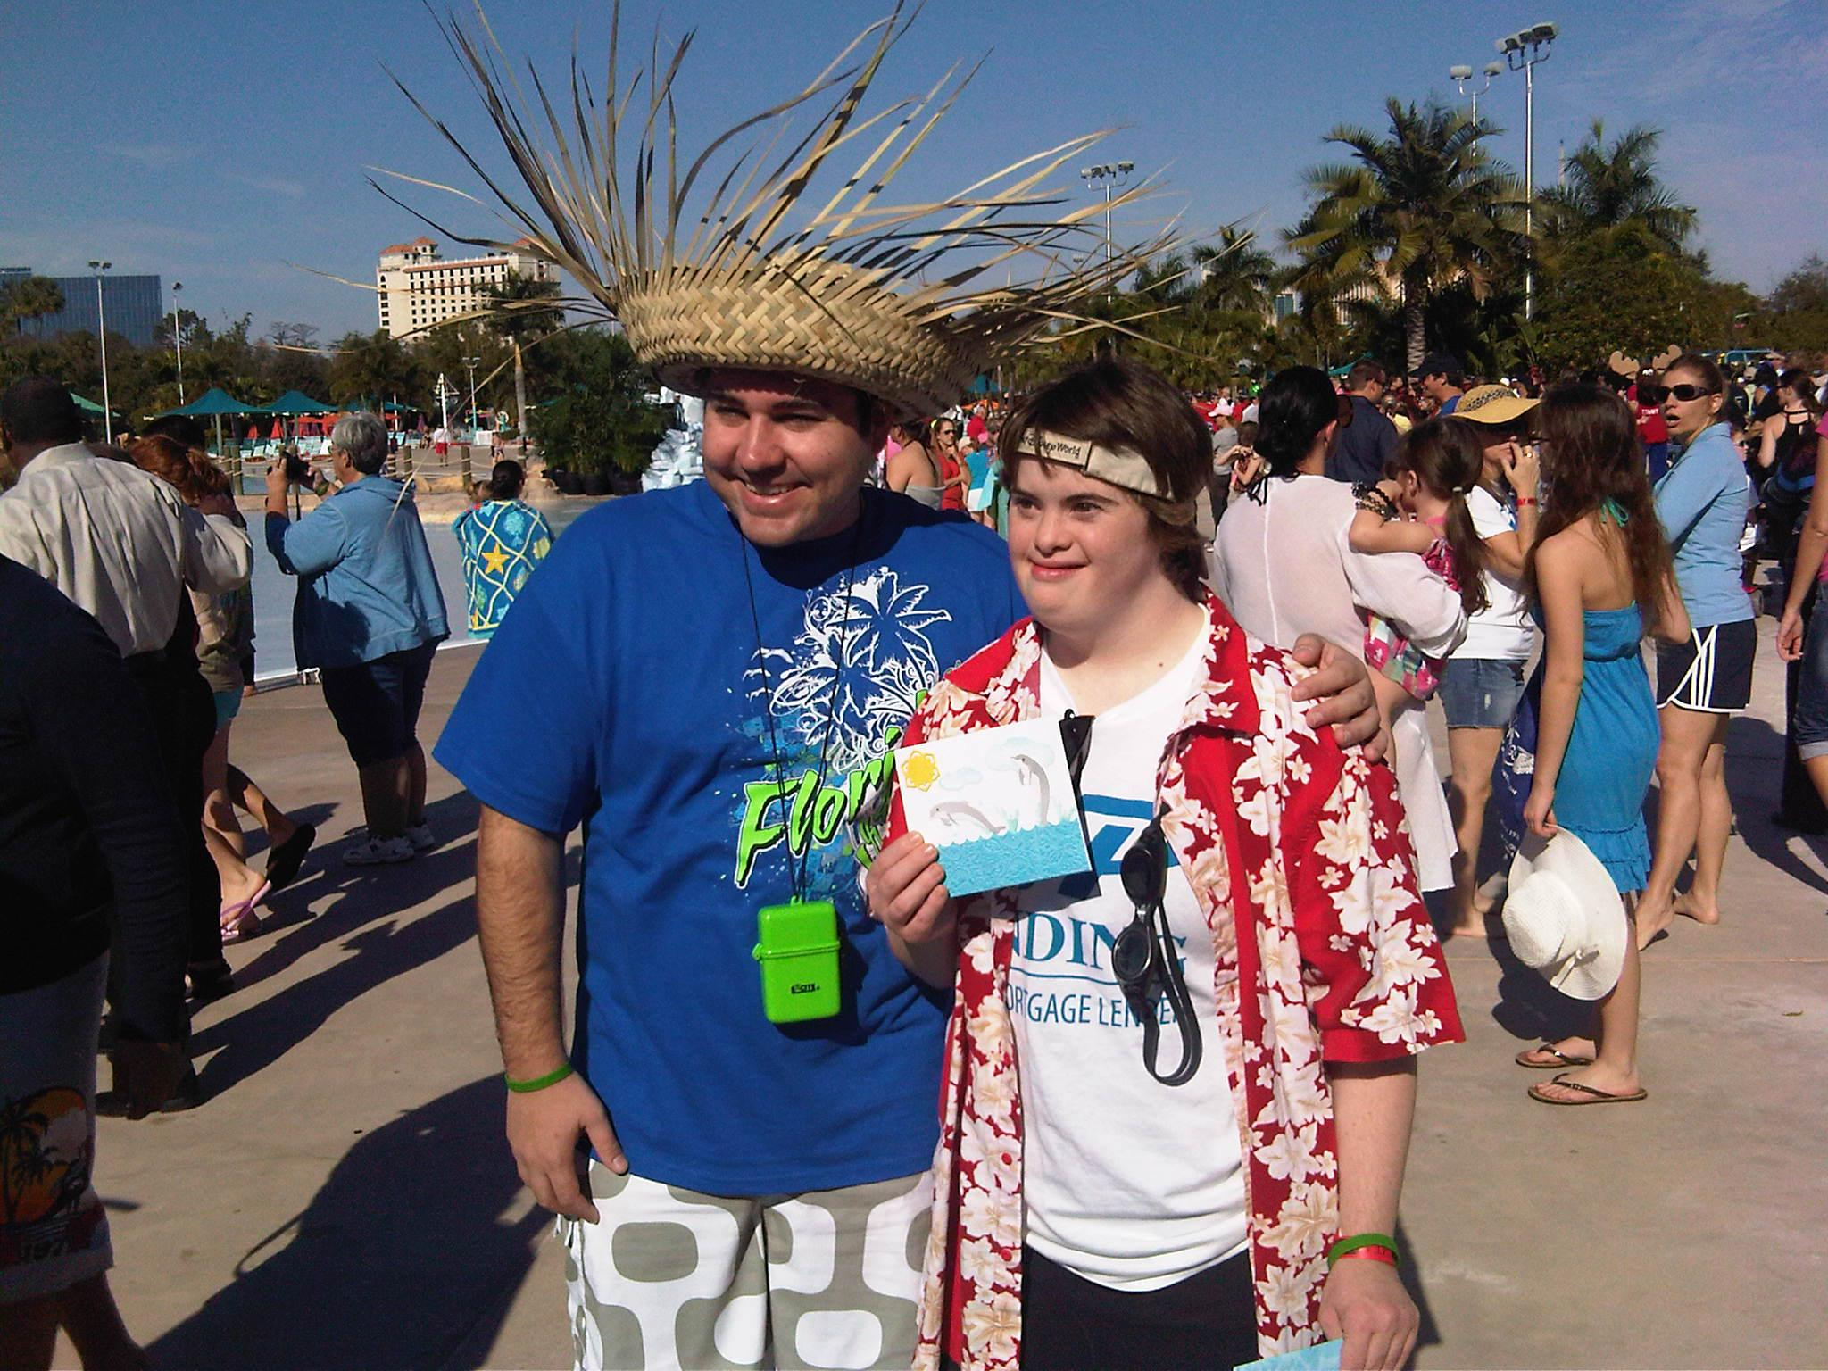
Photo courtesy Special Olympics Florida
Robert Palmer, president of Orlando-based RP Funding, is once again teaming up with Special Olympics athlete Kristin Costanzo during the annual Polar Plunge Feb. 2 at Sea World’s Aquatica.
# # #

